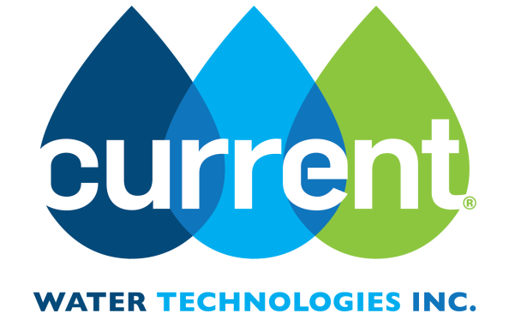

T-S2 CUSTOMER SPECIFICATION FORM
Complete form and return by email to:
info@currentwatertechnologies.com
To Be Completed By CWTI
Staff Initials
Product: |  | Deionization
 |  | Ammonia Removal
 |  | Nitrate Removal
 |  | AMD Prevention
 |  | Metals Recovery

Date | Click here to enter text.
Organization /  Client Name | Click here to enter text.
Primary Contact  Name | Click here to enter text.
Address | Click here to enter text.
Tel | Click here to enter text.
Fax | Click here to enter text.
Email | Click here to enter text.

Objectives and General Questions
- What is the objective of the treatment? (Improved removal of salts (TDS), higher water recovery, removal of nutrients, etc.)
Click here to enter text.

- What criteria would determine the success of the treatment? Time frame?
Click here to enter text.

- What are the justifications for the treatment? (Reduced operating cost, compliance, avoiding fines, reducing environmentally related complaints, etc.?
Click here to enter text.

- To what extent can a process improvement in your facility affect the treatment? (Such as waste dilution, nutrient amendment, process control changes, etc.)
Click here to enter text.

- What alternative treatment options are being considered?
Click here to enter text.

- Please list treatments used in the past or presently.
Click here to enter text.

 | Unit | Current | Desired |  | Unit | Current | Desired
Flow Rate | L/s |  |  | Other Elements
 | m³/day
Total Dissolved Solids (TDS) | mg/L
Total Suspended Solids (TSS) | mg/L
Hardness (as CaCO₃) | mg/L
Alkalinity (as CaCO₃) | mg/L
Electrical Conductivity | µS/cm
Temperature | °C
pH
METALS
Al | mg/L
Ag | mg/L |  |  | Organic Components
As | mg/L
Ca | mg/L
Cr | mg/L
Fe | mg/L
K | mg/L
Mg | mg/L
Mn | mg/L
Na | mg/L
Ni | mg/L
NH₃-N | mg/L
Pb | mg/L |  |  | Other Parameters
P | mg/L
Zn | mg/L
ANIONS
Br | mg/L
Cl | mg/L
HCO₃ | mg/L
F | mg/L
NO₃-N | mg/L
SO₄ | mg/L

Questions? Contact us at: | info@currentwatertechnologies.com  Toll free: (800) 811-6216  Tel: (519) 836-6155  Fax: (519) 836 5683 | 4-70 Southgate Drive  Guelph, Ontario, Canada  N1G 4P5  www.currentwatertechnologies.com

